**Semester 2: Programming Fundamentals I - CA Exam**

**Instructions:**

* In this exam you will write a program from scratch. However, you have access to the EasyScanner class which you can download from the assignment dropbox in Moodle.
* The runtime version of this exam can be downloaded from the assignment dropbox in Moodle.
* The sample output and the runtime version is provided, please use it as a guide.
* You are required to write the java code for the class diagram and UML diagram below.
* The exam is 1 hour and 15 minutes long; ensure you allocated enough time to test your code prior to submission.
* When you are finished your exam, zip it up and rename it to your full name e.g. SineadWalsh.zip and upload it into the assignment dropbox in Moodle.
* Read the entire question before you start.

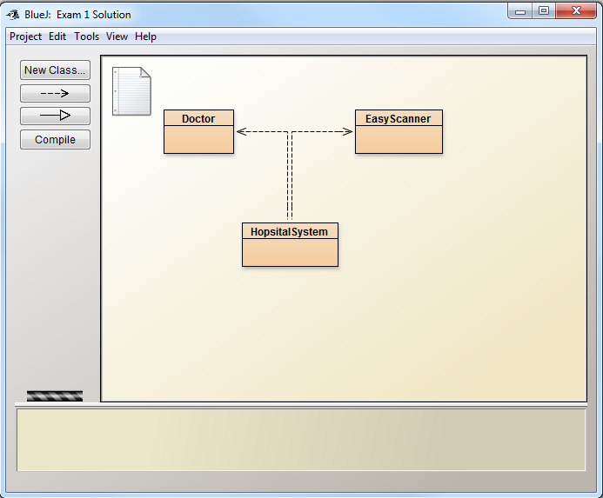

You are required to complete the following class and application classes for the UML diagram below.

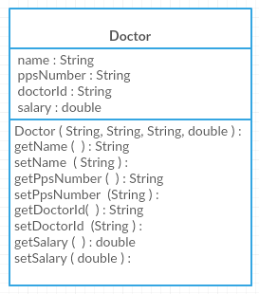

Write a class called Doctor.

1. It contains the following attributes name, pps number, doctor id and salary.
2. The constructor will set **all** the attributes.
3. Each attribute should have an accessor (get) and a mutator (set) method.

Now write the application class called HospitalSystem. In your application class you are to:

1. Ask the user how many doctors they are creating in the system. You are then to create an array of doctors based on the number the user entered.
2. You are now to create all the doctors in the system. You must ask the user to enter the doctor’s details. You must use a loop to do this. (HINT: ensure you create the objects and put them in the array).
3. You are then to print out all the doctors’ details to the screen, again using a loop.
4. All the doctors’ ids are changing. You must ask the user to enter in the new doctor ids and change them. You must again use a loop to do this.
5. Again print out all the doctors’ details to the screen, using a loop.
6. All the doctors get a raise so you must increase their salary by 1000 euro.
7. Again print out all the doctors’ details to the screen, using a loop.
8. As you can see in step **3, 5 and 7** you are doing the same task. You are to use a method to do this.

**See sample output below, also see runtime version on Moodle.**

**Sample Output**

